**ASSIGNMENT 3.2**

1. **WAP to make simple calculator (operation include Addition, Subtraction, Multiplication, Division, modulo).**

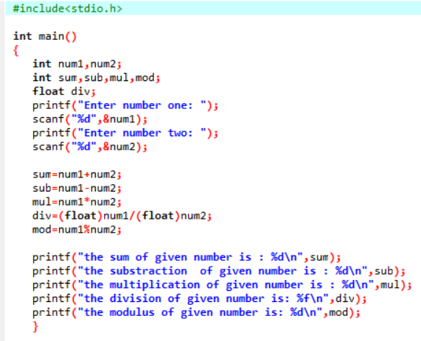

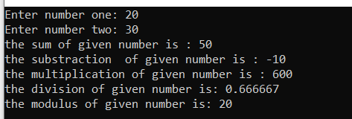

1. **WAP to swap two numbers without using third variable.**

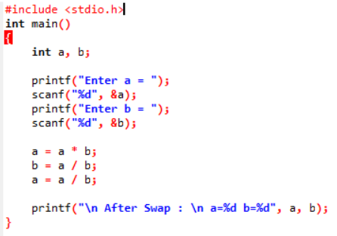

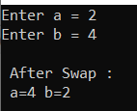

1. **WAP to find number is even or odd using ternary operator.**

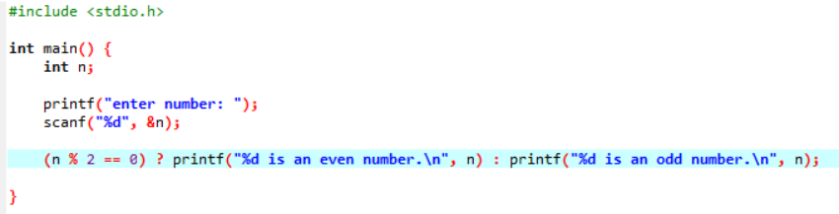

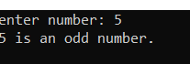

**(4) WAP to show**

**1. Monday to Sunday using switch case**

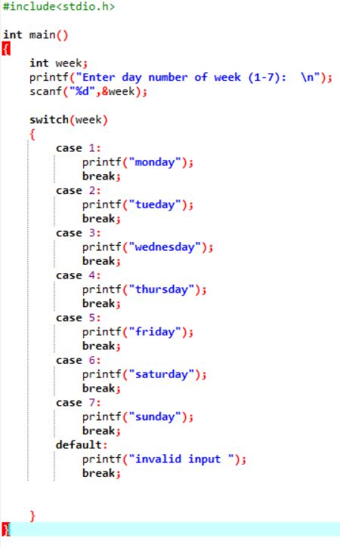

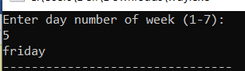

1. **Vowel or Consonant using switch case**

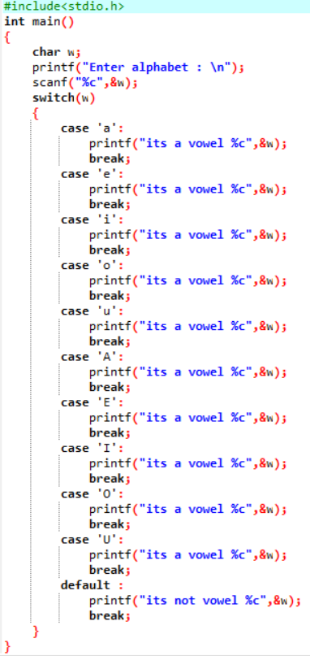

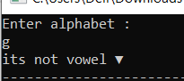

**(5) Looping programs:**

**1. WAP to print 972 to 897 using for loop**

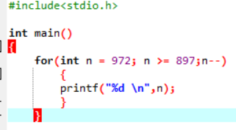



1. **WAP to take 10 no. Input from user and find out …**

**3. How many Even numbers are there**

**4. How many odd numbers are there**

**5. Sum of even numbers**

**6. Sum of odd numbers WAP to print table up to given numbers**

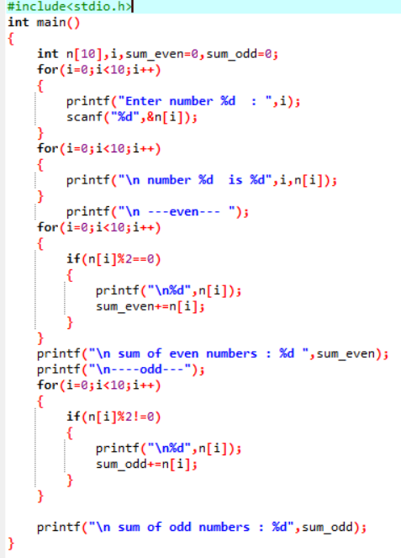

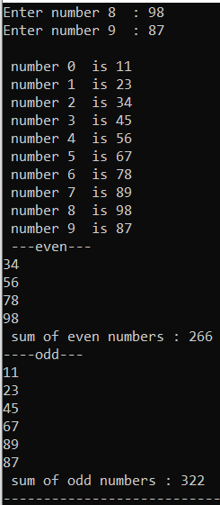

**(6) WAP to print table up to given numbers**

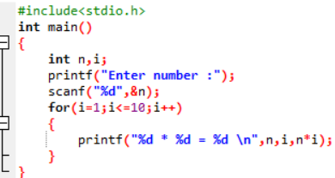

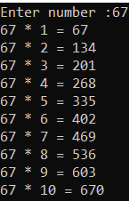

1. **WAP to print factorial of given number.**

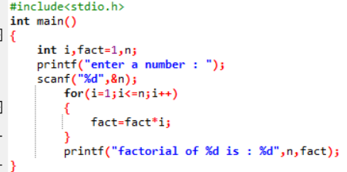



1. **WAP to print Fibonacci series up to given numbers.**

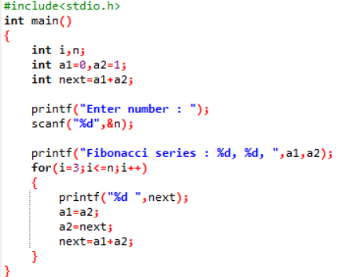



1. **WAP to print number in reverse order e.g.: number = 64728 ---> reverse = 82746**

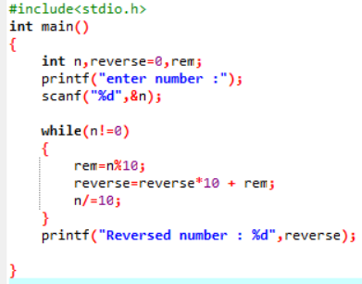



1. **Write a program to find out the max from given number (E.g., No: -1562 Max number is 6).**

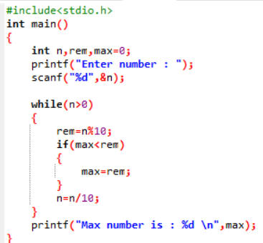

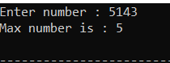

1. **Write a program make a summation of given number (E.g., 1523 Ans: -11)**

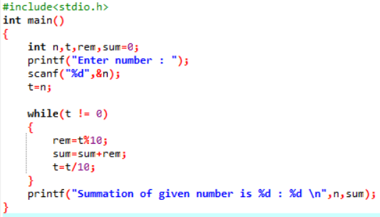

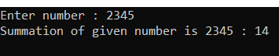

1. **Write a program you have to make a summation of first and last Digit. (E.g., 1234 Ans: -5)**

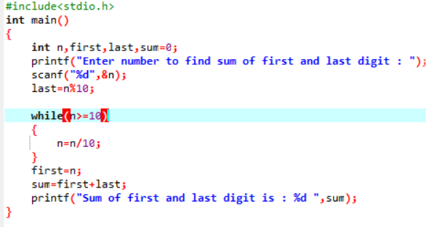



1. **Patterns :**

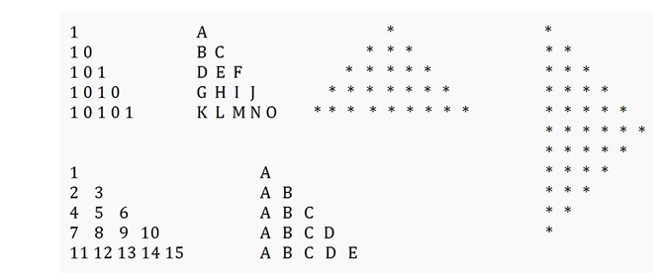

**P1:**

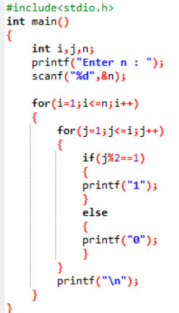

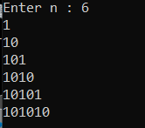

**P2:**

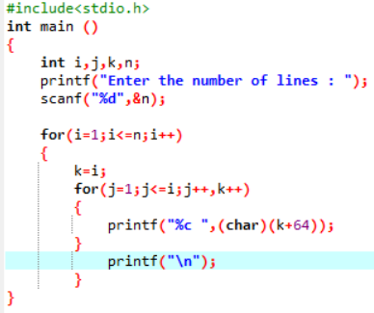

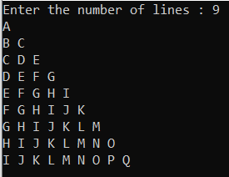

**P3:**

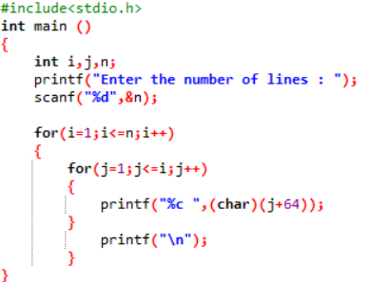

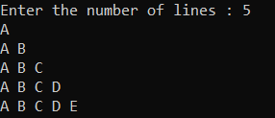

**P4:**

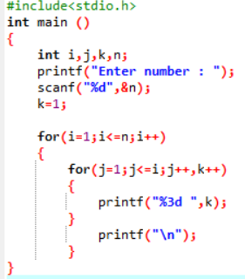

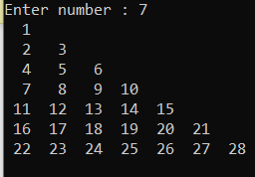

**P5:**

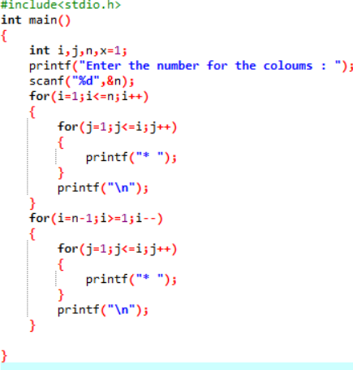

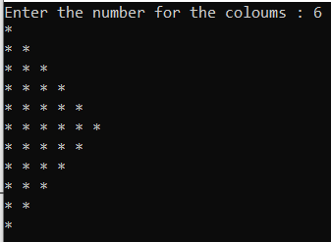

**P6:**

